Nisani Das  Summary  Dedicated and detail-oriented individual seeking an entry-level position as a Software Tester to leverage strong analytical and problem-solving skills in ensuring software quality and functionality. I am currently working as a Freelancer with some online testing communities like uTest, Userfeel, TryMyUI, TestBirds etc. Looking for a full-time/Part-time position in relevant testing areas based on my experience and education.  Experience  Manual Testing  Freelance - Tampa, FL  Google AI Project (Freelance):  - Conducted manual testing for an AI project through the Utest platform for four months.  Usability Testing for Userfeel:  - Achieved certification as a Usability Tester from Userfeel.  - Conducted usability testing for healthcare websites and tested quantitative prototypes for Userfeel.  Try My UI Testing (Certified):  - Certified as a tester by Try My UI after successfully testing www.bbc.com webpage.  - Completed testing and identifying bugs on Ben & Jerry's webpage, documented testing procedure, and listed identified bugs.  Usability Testing for TestBird:  - Conducted usability for Ben and Jerry's webpage as part of a TestBird project.  Education and Training  Bachelor of Arts, Arts With Economics, 06/2007  The University of Burdwan - Burdwan, West Bengal, India  Languages  English: Professional: Bengali: Native/ Bilingual:  Hindi:  Limited:  Additional Information  - Exploring innovative testing methodologies and tools.  - Learning and adopting software quality assurance best practices.  - Staying updated with the latest trends in the software testing industry.  Accomplishments  - AT*SQA Micro-Credential Certificate recipient.  - Recognized in the Testing Tiers® Software Tester Rankings on the official AT*SQA testing page.  - Demonstrated efficiency and dedication as a freelance tester.  Certifications  - Certified Tester ISTQB® Foundation Level (CTFL) from Udemy.  - Test Automation Foundations from Udemy.  - AT*SQA Test Automation Micro-Credential Certificate.  - AT*SQA Test Approaches Micro-Credential Certificate.  - AT*SQA Usability Testing Micro-Credential Certificate.  - AT*SQA CyberSecurity Micro-Credentials. |  | 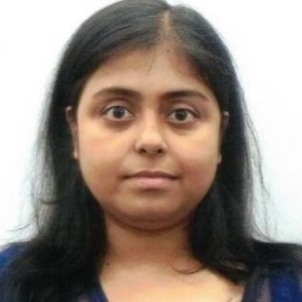  Contact  Address : Tampa, FL 33647  Phone : 8134042630  Email : dasnisani@gmail.com  Skills  - Manual testing methodologies and techniques.  - Bug tracking and reporting.  - Test case creation and execution.  - Understanding of software development lifecycle (SDLC).  - Currently pursuing a Python course on Udemy.

