|  |  |  |  |  |  |
| --- | --- | --- | --- | --- | --- |
| Company Name | Redbytes Software Pvt.Ltd | | | | |
| Job Title | QA Manual | | | | |
| Min Qualification | Bachelor’s degree in computer science, information technology, or a similar field. | | | | |
| Optimal Experience | 2 to 5 Yrs | **Salary Range** | 10LPA to 12LPA | **Location** | Bangalore |
| Job Description | The role is that of a typical QA Manual tester who is required to understand the technical requirements of the equipment systems and then work on evaluating the code and detecting the bugs in them by developing good testing scenarios. The Job required the candidate to be calm, calculative, collected and extremely thoughtful. The Role would need an Individual Contributor with Excellent communication skill and an ability to share their findings to various teams with confidence and clarity. | | | | |
| Job Responsibilities  (Limit to NMT 12) | 1. Analysing the technical characteristics of equipment systems. 2. Evaluating written code to ensure it meets project specifications. 3. Developing quality assurance strategies and organizing phased testing with QA engineers 4. Helping with bug detection and fixing 5. Conducting product testing after its presentation 6. Testing and analyzing the results 7. Monitoring errors in the system and discussing them with other colleagues | | | | |
| Other Expectations  *(Language, Skills,*  *Prior Know How, etc)* | Should have Experience with the following:   1. Manual Testing (2+ yrs) 2. Functional and Regression Testing (2+ yrs) 3. API Testing: Postman (2+ yrs) 4. DB Testing (1.5+ yrs) 5. Web and Mobile App Testing (1+ yrs each) | | | | |
| *Any Other Notes* | The candidate would be working with the Client from the Client Office in Bangalore.  The candidate would be on Redbytes Payroll.  The Candidate would be required to Join by Enter Date  The candidate would be paid a Joining Bonus of 50,000 by Redbytes when they get hired and Join the company and complete 3 months. | | | | |

On the next page, please use the information from this section to select of the most desirable behavioural characteristics that are expected by the person filling this role. Please try and select the characteristics that are necessary for the role and not what characteristics you consider are generally good or what you believe should be most important for a person in general.

|  |  |
| --- | --- |
| Instructions  *read carefully* | * You will see below a list of 12 Characteristics you may identify to be the most important for a role within your organisation. * Among them, select 6 Characteristics as required for your job. * Among the 6 selected, pick 2 as very important. * Use the statements in the first 4 columns as guidance on selection. |

|  |  |  |  |  |  |  |
| --- | --- | --- | --- | --- | --- | --- |
| Assigns tasks and follows up for Completion | Inspires people to achieve their goals | Tackle routine and predictable tasks / Plans | Takes up tasks requiring precision and accuracy | Characteristics | Required  (Fist Select 6) | Very Important  (Pick 2 among the 6) |
|  |  |  | Right pointing backhand index outline | **Accuracy**  *Correctness and Completeness* | Stop outline | Stop outline |
|  |  |  | Right pointing backhand index outline | **Cooperativeness**  *Generally Agreeable and Seeks Collective Solutions* | Stop outline | Stop outline |
| Right pointing backhand index outline |  |  |  | **Efficiency**  *Sense of Urgency, Organization and Resourcefulness* | Stop outline | Stop outline |
|  | Right pointing backhand index outline |  |  | **Enthusiasm**  *Excitement and Energy* | Stop outline | Stop outline |
|  | Right pointing backhand index outline |  |  | **Friendliness**  *Openness and Warmth, Sympathetic* | Stop outline | Stop outline |
| Right pointing backhand index outline |  |  |  | **Independence**  *Free from needing support and direction* | Stop outline | Stop outline |
|  |  | Right pointing backhand index outline |  | **Patience**  *Tolerance for delays, challenges, and difficulties* | Stop outline | Stop outline |
|  |  | Right pointing backhand index outline |  | **Persistence**  *Ability to Stick to a Subject in-spite of opposition* | Stop outline | Stop outline |
|  | Right pointing backhand index outline |  |  | **Self Confidence**  *Faith in self for abilities and judgement* | Stop outline | Stop outline |
| Right pointing backhand index outline |  |  |  | **Self-Motivation**  *Being a Self-Starter and Initiator* | Stop outline | Stop outline |
|  |  |  | Right pointing backhand index outline | **Sensitivity**  *Being aware of other’s feelings and impact of work* | Stop outline | Stop outline |
|  |  | Right pointing backhand index outline |  | **Thoughtfulness**  *Thinking carefully about things before acting* | Stop outline | Stop outline |

# Personality Selection

# Target Role Personalities

**100% Suitability**

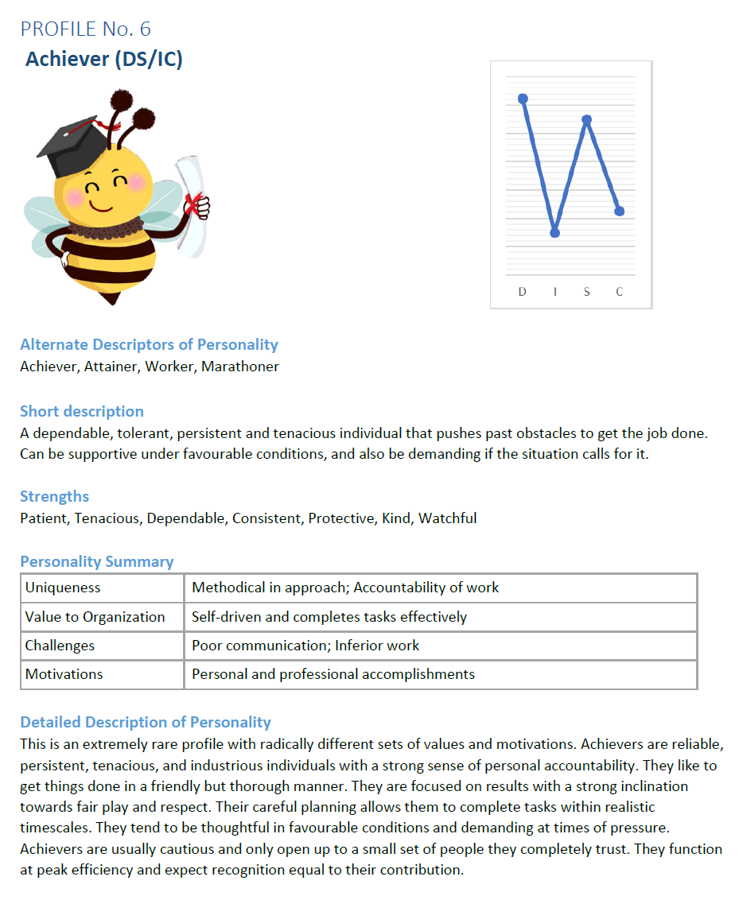

**85% Suitability**

**85% Suitability**

